Institution Logo/Letterhead

To: Challenge Grant Review Committee

From: Insert Institution President Name

Re: Authorized Designee for Grant or Scope Request Presentation

In accordance with N.D.C.C. 15-10-51 (4c):
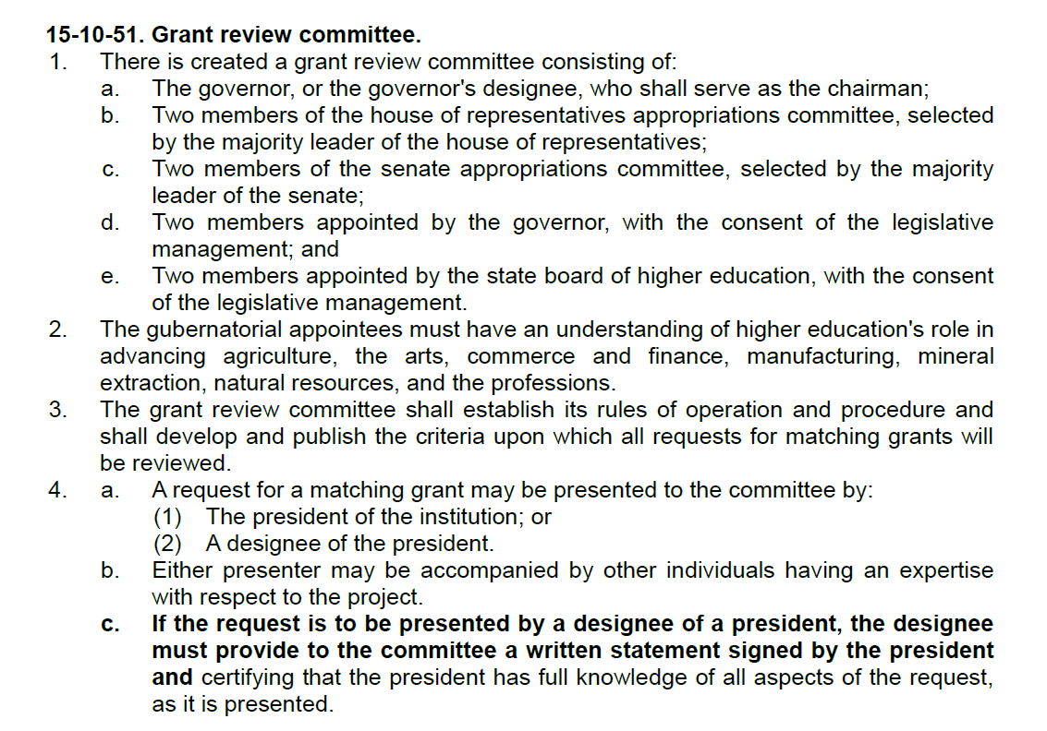
I hereby designate Insert Name of Designee to present in my absence, and I certify that I have full knowledge of all aspects of the request(s) as presented.

This designation is for the meeting date of Insert Date of Meeting only.

This designation is for the Insert Years of Biennium biennium.

Signature: ____________________________________________________
Typed Name & Title: Insert President Name, Title

Date: Insert Current Date

